HEAM Parliamentarian 2017  A school level debate competition [Exclusively for school students in XI or XII (State, CBSE and ICSE)] to create the awareness about - Necessity of Hydrogen and other renewable energy sources based startups in India  Date: 07/12/2017, Thursday  Venue  St. John’s College, Anchal, Kollam, Kerala  (Re-accredited with ‘A’ grade by NAAC, Recognized for STAR college scheme by DBT, Govt. of India, Funded under DST FIST scheme, Govt. of India )  Organized by  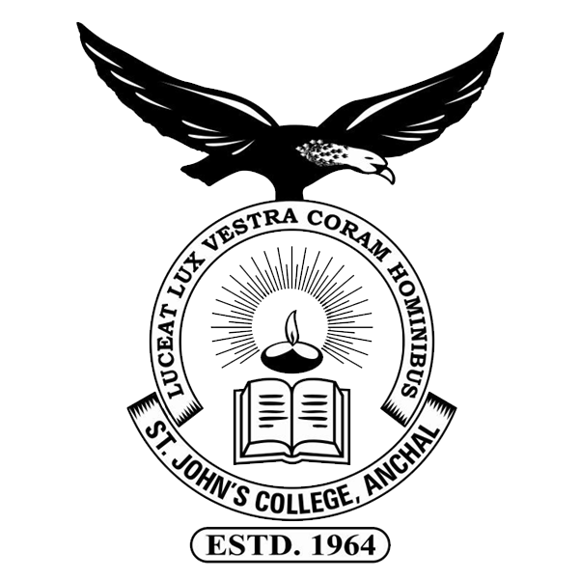  Department of Chemistry,  Innovation & Startup Club and Debate club,  St. John’s College, Anchal.  in association with    Indian Association for Hydrogen Energy and Advanced Materials  and  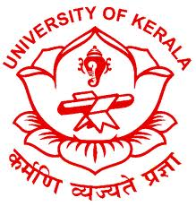  Department of Chemistry,  University of Kerala  Debate Topic: Necessity of Hydrogen and other renewable energy sources based startups in India  The interested students should send the duly filled registration form (see next page) to arunpsvjmd@gmail.com (Cc to:hydrogenmela@gmail.com) along with a write up(not more than 150 words) regarding recent challenges in hydrogen production/ storage/ transport/ hydrogen fuelled vehicles on or before 02/12/2017. The write-up will be evaluated by an expert committee. The selected students will be intimated on 03/12/2017.  In this programme the selected teams will get seated round the Hall to debate on the given topics. The participating teams’ awareness about the remedy of future problems by renewable energy sources, style of debating, focusing their individual ideas, countering the feasibility of others’ ideas, their immediate focus as the minister concerned, the need of hydrogen energy, the role of school children in creating more awareness etc. will be evaluated during their debate. The debate will be finally adjudicated by the juries to select the team of HEAM Parliamentarians 2017.  The team of HEAM Parliamentarian 2017 will be given a cash award of Rs. 10,000. All the participants will receive a participation certificate.  Programme (07-12- 2017)  Registration: 09.00 – 09.30 a.m.  09.45 a.m. : Introduction  10.00 a.m. : Invited Talk – I  10:30 a.m. : Invited Talk – II  11.00 a.m. : Tea  11.20 a.m. : Students Parliament  12.30 p.m. : Summary  12.45 p.m. : Issue of certificate and prize distribution | HEAM Parliamentarian 2017  Registration Form  (To be submitted by E-mail to: arunpsvjmd@gmail.com and Cc to: hydrogenmela@gmail.com  Name / Class / Division of the participants in the team (in block letters):  1.  2.  School Name:  Address with email:  Telephone numbers:  School:  Teacher in-charge:  Participants: 1.  2.  Endorsement by the School Principal:  Signature / School Seal:  (Required on 07/12/ 2017)  Any other Remarks:  - The team members must be students of XI or XII (State, CBSE and ICSE). Students from other classes will not be allowed to participate.  - No T.A / D.A will be given.  - One Team from one school.  - Each team consists of two students.  - Number of teams may be restricted by first come first serve basis.  - Print out of the duly filled registration form attested by the Principal must be produced on 07/12/2017.  Registration fee: There is no Registration fee  Contacts:  www.iaheam.org  Ph: 9995767819 (Dr. Arun P. S.)  Ph: 7994565916 (Mr. Sooraj, R. S.)  Ph: 8547067230 (Dr. S.M.A. Shibli)  E-mail: arunpsvjmd@gmail.com;smashibli@yahoo.com  The organizing Committee  Rev. Dr. James Steephen Olikal  (Principal, St.John’s College)  Dr. S. M. A. Shibli (President, IAHEAM)  Dr. Thomas Mathew (HoD, Chemistry, St.John’s College)  Dr. Arun, P. S. (Convener)  Theme Coordinators  Mr. M. Shaneeth (VSSC (ISRO) Trivandrum)  Dr. Bipin Kumar Gupta (NPL, New Delhi)  Mr. Sooraj R. S (Department of Chemistry, University of Kerala )  Ms. Aarcha Vijayan (Department of Chemistry, University of Kerala)  Ms. Anu Varghese (Convenor, Innovation & startup club)  Dr. Jinu M. John (Teacher coordinator)  To reach St. John's College, Anchal  From Trivandrum: St. John's College is 60 kms from Trivandrum and is only 8 kms away from Ayoor which is on the MC Road between Trivandrum and Kottarakkara. From Kollam: St. John's College is 40 kms from Kollam, KSRTC and private buses plying from Kollam to Anchal in every half an hour.  From Punalur: St. John's College is 12 kms from Punalur, KSRTC and private buses plying from Punalur to Anchal.

